**Finals Task 3. Simple Polymorphism**

**Problem. Chirp and Tweet**

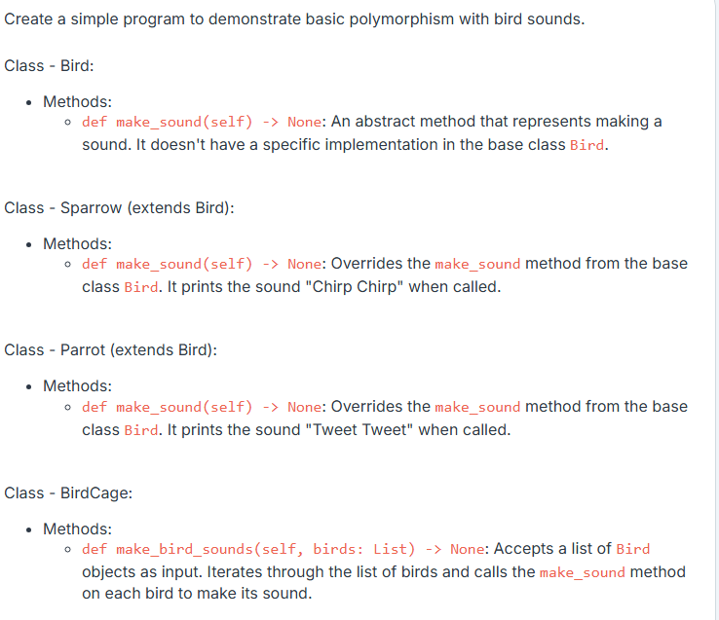

*Note:*

* *The test cases are not outputs of your main file but of a hidden test file. Create and implement the classes instructed to test your code.*
* *Each class should be defined in its own file, with the file name following camelCase conventions (e.g., bankAccount.py).*

*TEST CASES:*

